**CLOUD COMPUTING LAB – 1**

Name : Sanmat Sanjayakumar Payagoudar

SRN : PES1UG20CS385

Section : G

**Introduction to Amazon EC2**

1. Summary of instance before launching (Review Instance Launch)

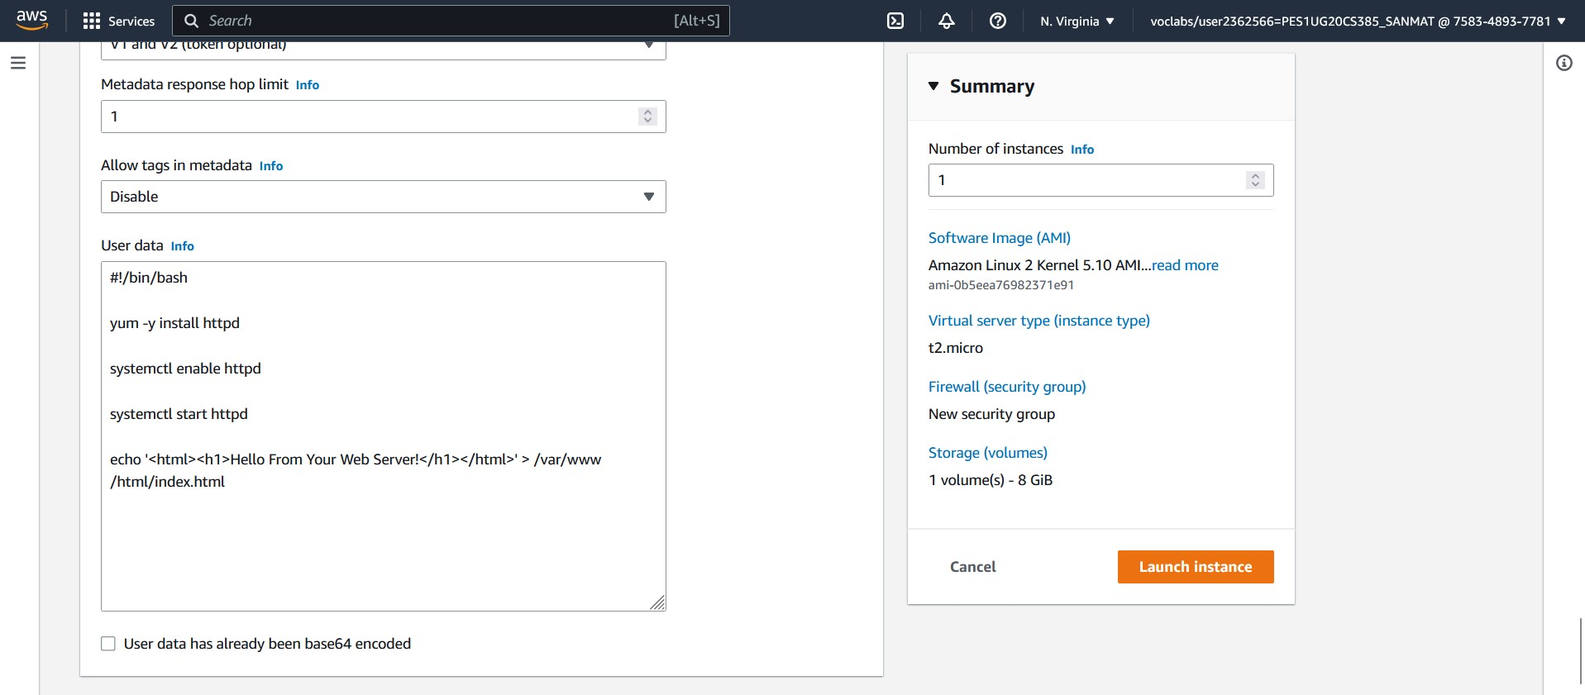

1. EC2 instance in running state

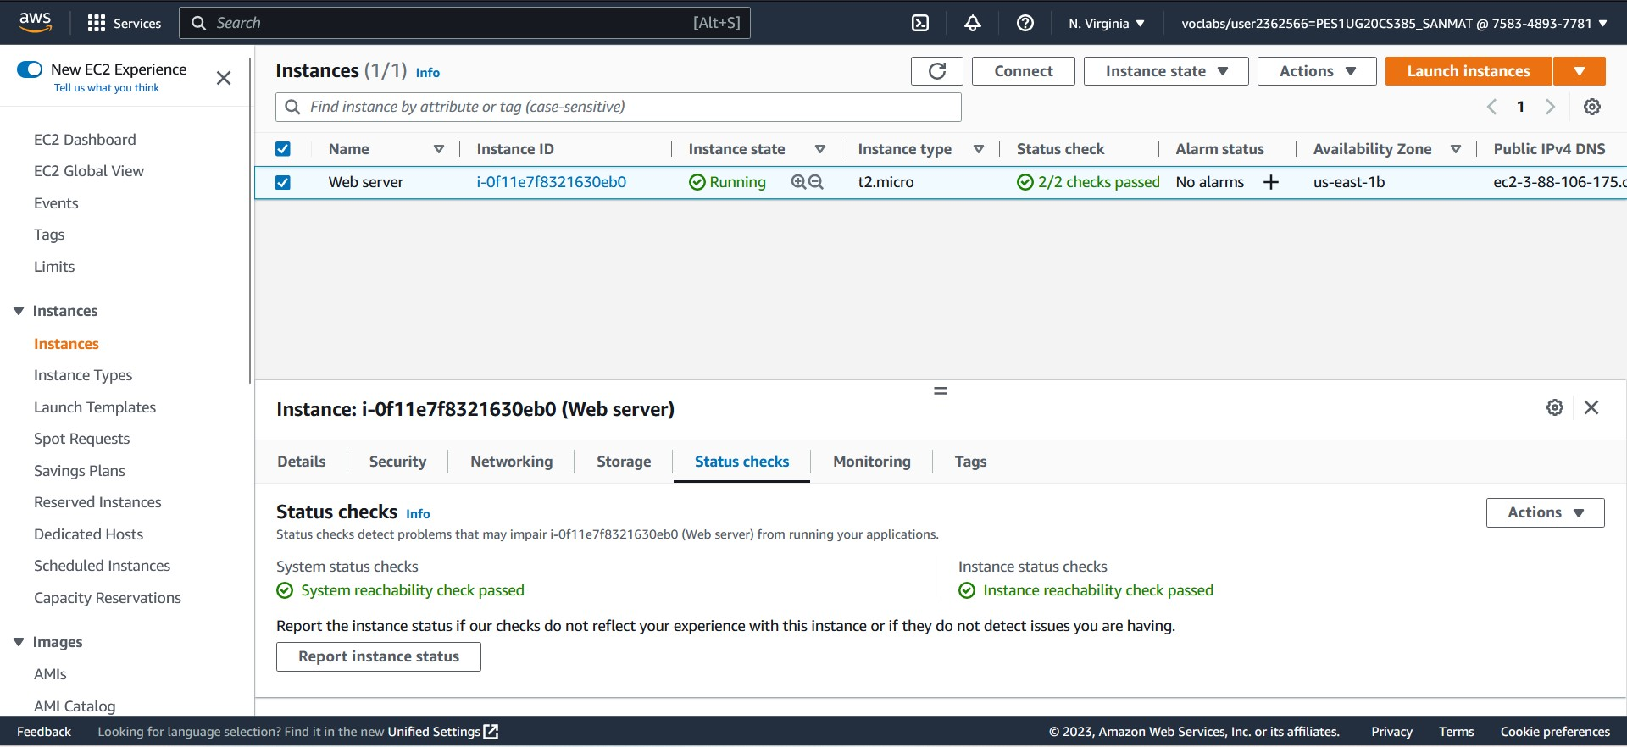

1. Web server browser with the message displaying



1. Showing the instance volume resized

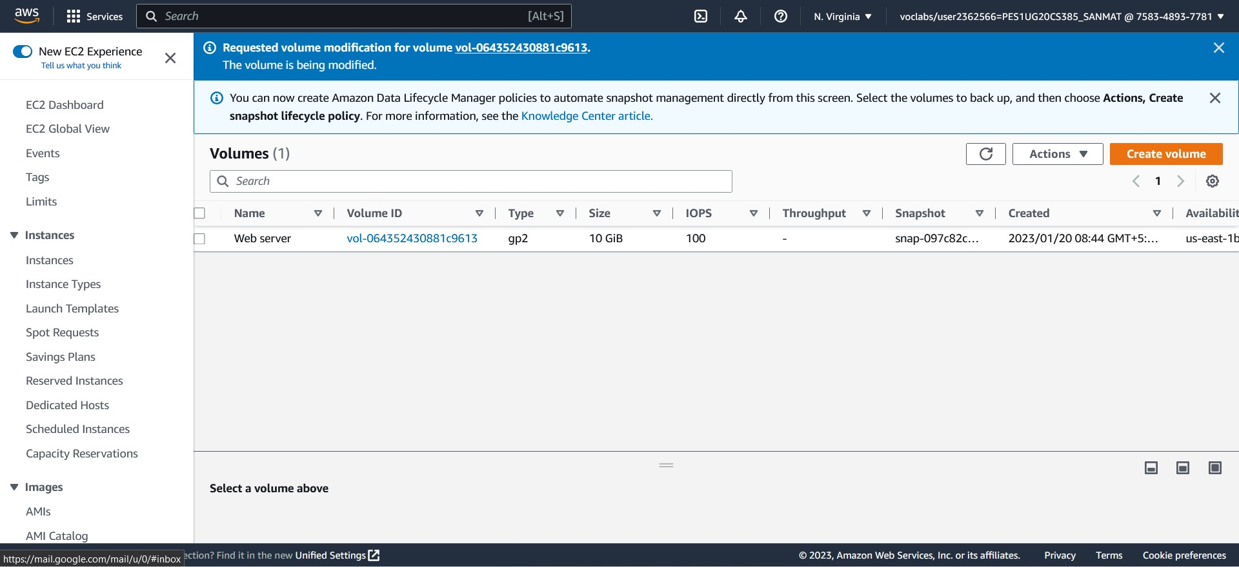

1. EC2 instance in stopped state

